Introduction To Deep Learning

What is deep learning?
- In the past few years, artificial intelligence (AI) has been a subject of intense media hype.
- Machine learning, deep learning, and AI come up in countless articles, often outside of technology-minded publications.
- We’re promised a future of intelligent chatbots, self-driving cars, and virtual assistants—a future sometimes painted in a grim light and other times as utopian, where human jobs will be scarce and most economic activity will be handled by robots or AI agents.

Artificial intelligence, machine learning, and deep learning

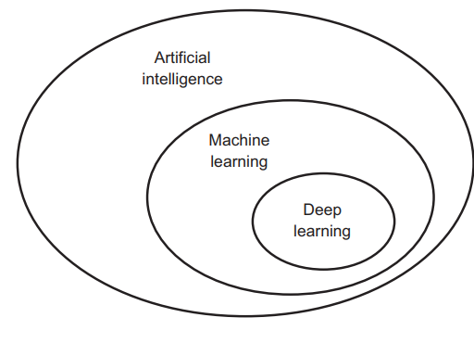
Artificial Intelligence (AI), Machine Learning (ML), and Deep Learning (DL) are interrelated fields but have distinct characteristics and applications.

Artificial Intelligence (AI)
- Definition: AI is the broader concept of machines being able to carry out tasks in a way that we would consider “smart”. It encompasses a wide range of technologies and approaches that enable computers to perform tasks that typically require human intelligence.
- Applications: AI is used in various applications including natural language processing (NLP), robotics, game playing, and expert systems. Examples include virtual assistants like Siri and Alexa, and recommendation systems used by Netflix and Amazon.
- Techniques: It includes rule-based systems, search algorithms, knowledge representation, reasoning, and decision-making algorithms.

Symbolic AI (1950s - 1980s)
- Definition: Symbolic AI refers to a branch of AI where intelligence is achieved through explicitly programmed rules and logic.

- Approach: In symbolic AI, programmers craft a large set of explicit rules to manipulate knowledge. These rules are predefined and do not change; they are hardcoded into the system.
- Example: Early chess programs used symbolic AI, where the moves and strategies were directly programmed by experts.
- Belief: For a long time, many experts believed that human-level AI could be achieved by developing a comprehensive set of rules for every possible situation.
- Peak Popularity: Symbolic AI reached its height during the 1980s with the rise of expert systems, which were designed to mimic the decision-making ability of a human expert in specific domains.

- Limitations of Symbolic AI

- Well-defined Problems: Symbolic AI worked well for well-defined, logical problems. For example, playing chess or solving mathematical equations where rules and outcomes are clear.
- Complex Problems: Symbolic AI struggled with complex, fuzzy problems where rules are not easily defined. Examples include:
    - Image Classification: Recognizing objects in images, which involves a vast variety of shapes, colors, and contexts.
    - Speech Recognition: Understanding and processing human speech, which varies widely in accents, intonation, and speed.
    - Language Translation: Translating languages, which requires understanding context, idioms, and nuances.

- Symbolic AI was an early approach to artificial intelligence that relied on hardcoded rules crafted by programmers.
- While it was successful for well-defined tasks, it couldn't handle more complex problems.
- This led to the rise of machine learning, where systems learn from data rather than relying on a vast set of predefined rules.
- Machine learning, and especially deep learning, has proven to be far more effective in dealing with the complexities of real-world data.

Machine Learning
New Approach:
- Machine learning fundamentally changes how we approach problem-solving with computers.
- Rather than manually programming rules (Symbolic AI), we let computers learn from data.
- This enables them to tackle complex tasks, adapt over time, and often surprise us with insights and solutions that go beyond our explicit instructions.
Learning from Data:
- Instead of explicitly programming rules, machine learning involves creating models that can learn from and make predictions based on data.

Classical Programming (Symbolic AI)
- Process:
  - Input: Programmers manually craft rules (a program).
  - Input: Data to be processed according to these rules.
  - Output: Answers or results produced by applying the rules to the data.
- Example: In a chess program, programmers would define all possible moves and strategies.

Machine Learning (ML)
- Process:
  - Input: Humans provide data (input data) and the expected answers (output data).
  - Output: The machine learning model learns the rules from the data.
  - Application: These learned rules can then be used to make predictions or produce answers on new, unseen data.

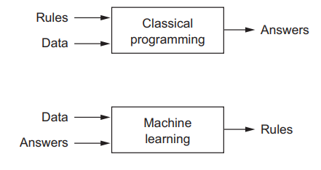

Adaptability:
- Machine learning models can adapt and improve over time as they are exposed to more data. This makes them suitable for complex, fuzzy problems that symbolic AI struggled with.
Examples:
- Modern applications like image classification, speech recognition, and language translation are now predominantly handled by machine learning and, more specifically, deep learning techniques.
Application of Learned Rules
- Once a machine learning model has been trained (learned the rules), it can apply these rules to new data to make predictions or generate answers. For instance:
  - Image Classification: The model can classify new images it has never seen before.
  - Speech Recognition: The model can transcribe new audio recordings.
  - Language Translation: The model can translate text from one language to another, even if it encounters new phrases or contexts.
- Although machine learning only started to flourish in the 1990s, it has quickly become the most popular and most successful subfield of AI.

Deep Learning (DL)
- Definition: DL is a specialized subset of ML that uses neural networks with many layers (hence “deep”). These deep neural networks are capable of learning complex patterns in large amounts of data.
- The deep in deep learning isn’t a reference to any kind of deeper understanding achieved by the approach; rather, it stands for this idea of successive layers of representations. How many layers contribute to a model of the data is called the depth of the model.
- Structure: DL models, also known as deep neural networks, are composed of multiple layers of nodes, with each layer transforming the input data into more abstract representations.
- Applications: DL is particularly effective in image and speech recognition, natural language processing, game playing, and autonomous driving. Examples include convolutional neural networks (CNNs) for image processing and recurrent neural networks (RNNs) for time series and sequence data

Deep Learning: A Mathematical Framework
- Deep learning (DL) is often misunderstood due to its name and the way it is sometimes compared to neurobiology.
- It is best understood deep learning as a powerful mathematical framework for learning from data.
- It involves training deep neural networks to transform and interpret complex data through multiple layers of computation.

Neural Network (also artificial neural network or neural net, abbreviated ANN or NN)
- A neural network is a method in artificial intelligence that teaches computers to process data in a way that is inspired by the human brain.
- It is a type of machine learning process, called deep learning, that uses interconnected nodes or neurons in a layered structure that resembles the human brain.
- The human brain is the inspiration behind neural network architecture.
- Human brain cells, called neurons, form a complex, highly interconnected network and send electrical signals to each other to help humans process information.
- Similarly, an artificial neural network is made of artificial neurons that work together to solve a problem.
- Artificial neurons are software modules, called nodes or units.

- These are connected by edges, which model the synapses in a brain.
- The whole Artificial Neural Network is composed of these artificial neurons, which are arranged in a series of layers.
- The complexities of neural networks will depend on the complexities of the underlying patterns in the dataset whether a layer has a dozen units or millions of units.
- A layer can have only a dozen units or millions of units as this depends on how the complex neural networks will be required to learn the hidden patterns in the dataset.
- Each artificial neuron receives signals from connected neurons, then processes them and sends a signal to other connected neurons.
- The "signal" is a real number, and the output of each neuron is computed by some non-linear function of the sum of its inputs, called the activation function.
- The strength of the signal at each connection is determined by a weight, which adjusts during the learning process.

Single Layer Perceptron
- It is one of the oldest and first introduced neural networks.
- It was proposed by Frank Rosenblatt in 1958.
- Perceptron is also known as an artificial neural network.
- Perceptron is mainly used to compute the logical gate like AND, OR, and NOR which has binary input and binary output.
- An SLP consists of a single layer of neurons (perceptrons) that directly connect the input to the output.
- A Single Layer Perceptron can only find a linear boundary to separate classes.
- If a single straight line (or hyperplane) can separate the classes, the SLP can learn this boundary.
The main functionality of the perceptron is:
- input layer: The input layer consists of input features represented as x1, x2,…,xn
- Weights and Bias: Each input feature xi​ is associated with a weight wi​. A bias term b is also included to adjust the output independently of the input features.
- Weighted sum: The perceptron computes a weighted sum of the input features
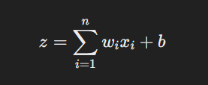
- Activation Function: The weighted sum z is passed through an activation function, typically a step function or a sigmoid function for binary classification.

For a step function:
- Here activation functions can be anything like sigmoid, tanh, relu Based on the requirement we will be choosing the most appropriate nonlinear activation function to produce the better result. Now let us implement a single-layer perceptron.

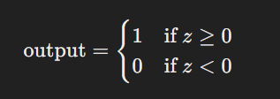

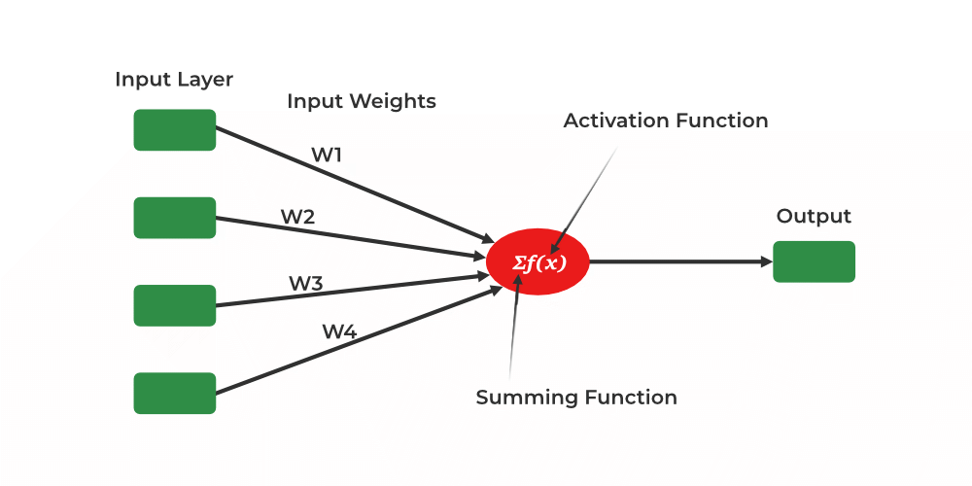
Working of a Single-Layer Perceptron
Forward propagation
- Initialization: Initialize weights wi​ and bias b with small random values.
- Forward Pass: For each input feature vector, compute the weighted sum z and apply the activation function to obtain the output.
- Loss Calculation: Calculate the loss, usually the mean squared error (MSE) or binary cross-entropy, between the predicted output and the actual target.

Backpropagation
Weight Update: Update the weights and bias using the gradient descent algorithm to minimize the loss. The weight update rule for a single-layer perceptron is:
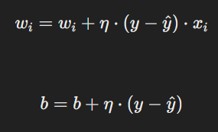
where η is the learning rate, y is the actual target, and y^​ is the predicted output.

Limitations
- Linearly Separable Data: SLP can only solve problems where the data is linearly separable (where you can draw a straight line (or a hyperplane in higher dimensions) that separates the data points of different classes.).
- It cannot solve problems like XOR where the classes are not linearly separable.
- Complexity: SLP cannot capture complex patterns in the data due to its single-layer structure. If the data is not linearly separable, meaning you cannot separate the classes with a single straight line, the SLP will fail to classify the data correctly.

Multi-layer Perceptron (MLP)
- To overcome the limitations of SLPs, multi-layer perceptrons (also known as deep neural networks) are used.
- These networks have one or more hidden layers between the input and output layers, allowing them to capture more complex patterns.

How the Dense Layer Processes Input
When you pass input data to a Dense layer with 64 neurons:
- Input Data:
- Suppose each input sample has 20 features
(e.g., X_train.shape[1] = 20).
- In a Dense layer, each of the 64 neurons receives the same input vector, but they process this input vector differently because they have different sets of weights and biases.
- if your input vector is x=[x1,x2,x3,…,x20], this same vector is fed into all 64 neurons.
- Weights and Biases:
  - Each of the 64 neurons will have its own set of 20 weights (one for each input feature) and one bias term.
  - Therefore, the total number of weights in this layer is
64×20=1280 plus 64 bias terms.
- Weighted Sum and Bias:
- For neuron j, let wj​ be its weights vector and bj​ be its bias. The weights vector wj​ has 20 components, one for each feature in the input vector.
- For each neuron j in the layer, the weighted sum zj​ is
- calculated as: 20
zj=∑ wjixi+bj
i=1
  - where w_{ji} is the weight associated with the i-th input feature for the j-th neuron, xi​ is the i-th input feature, and bj​ is the bias for the j-th neuron.
- Activation Function:
  - The ReLU activation function is applied to the weighted sum to produce the neuron's output:
  - aj=ReLU(zj)=max(0,zj)
- Output of the Dense Layer:
  - The output of this Dense layer is a 64-dimensional vector, where each element corresponds to the output of one of the 64 neurons.
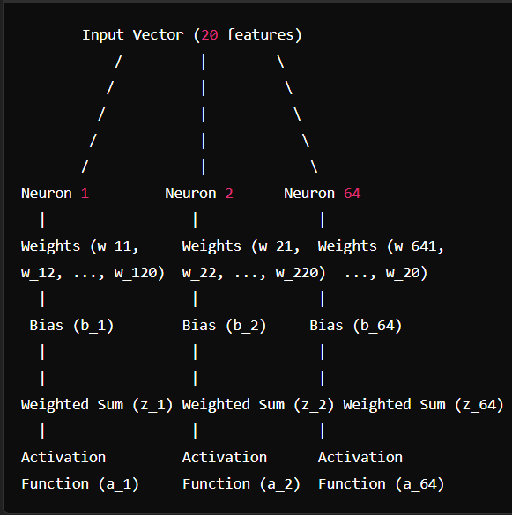
- In summary, each batch of input data is processed by all neurons in the Dense layer, and this process repeats for each batch until the entire dataset is processed.
- The first Dense layer accepts one row at a time from each batch, processes it through all 64 neurons, and then moves to the next row in the batch until all rows in the batch are processed. This continues for all batches in the dataset.

Dataset and Batch Processing
- Dataset:
  - Assume your dataset has 1 million rows and each row has 20 features.
  - Let’s denote the dataset as X and the labels as y.
- Batch Processing:
  - Neural networks typically process data in batches to efficiently utilize computational resources.
  - Suppose the batch size is 32. This means that during each iteration of training, the model processes 32 rows of data at a time.
Dense Layer with 64 Neurons
- First Batch:
  - The first batch contains the first 32 rows of your dataset.
  - Each row in the batch is an input vector with 20 features.
  - All 64 neurons in the Dense layer will process each of the 32 input vectors in the batch.
- Neurons Processing:
  - For each input vector, all 64 neurons will receive the same input vector but process it using their own unique set of weights and biases.
  - For example, if the first row is [x1,x2,...,x20] all 64 neurons will process this row simultaneously.
  - The output of each neuron for this row will be a scalar value.
  - If the neuron is in a hidden layer, its scalar output is sent to all neurons in the next layer.
  - Each neuron in the next layer treats the received value as one of its many inputs.
  - Each neuron in the next layer collects inputs from all neurons in the previous layer.
- Output of the Dense Layer:
  - After processing the entire batch, the Dense layer will produce an output matrix of shape (32, 64), where 32 is the number of rows in the batch and 64 is the number of neurons.
  - Each row in this output matrix corresponds to the output of the 64 neurons for one input vector in the batch.

- Iterating Over the Dataset
- The training process iterates over the entire dataset, processing it in batches.
- After the first batch (first 32 rows) is processed, the next batch (next 32 rows) is fed into the Dense layer.
- This process continues until all 1 million rows have been processed.
When the entire dataset is processed during training, it means one epoch is completed.
Epoch Completion
- Epoch:
  - An epoch is a single pass through the entire training dataset.
  - After one epoch, every sample in the dataset has been used once for training.
- Evaluation and Metrics:
  - At the end of an epoch, the model's performance on the training dataset and the validation dataset (if provided) is evaluated.
  - Metrics such as loss and accuracy are computed and reported.
Subsequent Epochs
- Multiple Epochs:
  - Training typically involves multiple epochs.
  - The number of epochs is a hyperparameter specified by the user.
  - For example, if you specify epochs=10, the model will go through the entire dataset 10 times.
- Shuffling Data:
  - Before starting a new epoch, the training data is often shuffled to ensure that the model does not see the data in the same order every time. This helps improve generalization and prevent overfitting.
Model Update
- Weight Updates:
  - During each epoch, the model's weights are updated multiple times (once per batch) based on the computed gradients and the optimization algorithm.
  - These updates aim to minimize the loss function.
- Validation:
  - If a validation set is provided, the model is evaluated on this set at the end of each epoch. This helps monitor the model's performance on unseen data and detect overfitting.
Early Stopping
- Early Stopping:
  - Early stopping is a technique where training is stopped before the specified number of epochs if the model's performance on the validation set stops improving.
  - This prevents overfitting and reduces training time.

Understanding Your Case:
- You set batch size = 32.
- You set epochs = 10.
- Let's assume your dataset has 1,000 rows.

How the Training Works:
- In one epoch, the model must go through all 1,000 rows.
- Since each batch contains 32 rows, the number of iterations per epoch is:
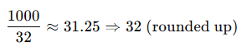
- So, in one epoch, the model will perform 32 iterations (each processing 32 rows).
- Since you set 10 epochs, the total number of iterations will be:
32×10=320 iterations in total

Summary
- Epoch: A complete pass through the entire dataset.
- Multiple Epochs: The model typically trains for multiple epochs to learn effectively.
- Shuffling: The training data is often shuffled between epochs to improve generalization.
- Weight Updates: The model's weights are updated after each batch to minimize the loss function.
- Validation: The model's performance is evaluated on a validation set after each epoch.
- Early Stopping: Training can be stopped early if the model's performance on the validation set stops improving.

Multiple Dense Layers
When a neural network has multiple dense layers, such as those with 64, 128, and 356 neurons, the working flow of data through these layers involves the transformation of inputs into progressively more complex representations.
1. Input to the First Dense Layer (64 neurons)
- Input Shape:
  - The input vector's shape depends on the dataset (e.g., if the dataset has 20 features, the input shape will be (20,)).
  - Example: Dense(64, activation='relu', input_shape=(20,)).
- Operation:
  - Each of the 64 neurons computes a weighted sum of all the inputs, adds a bias term, and applies the activation function (e.g., ReLU).
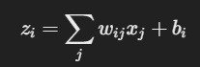
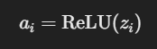
- zi​: Linear combination (weighted sum).
- ai​: Output after applying the activation function.
- wij​: Weight of the connection between input j and neuron i.
- bi​: Bias for neuron i.
- The output of this layer is a vector of size 64.

2. Output of First Layer → Input to the Second Dense Layer (128 neurons)
- Input Shape:
  - The output of the first layer (a vector of size 64) becomes the input to the second dense layer.
- Operation:
• Number of Parameters:
- Each neuron in the 128-neuron layer has 64 weights (one for each input) and 1 bias.
- Total parameters for this layer: (128×64)+128=8,320
• Processing:
- Each of the 128 neurons processes the same 64 inputs independently.
- Each neuron has unique weights and a unique bias, so their outputs are different.
• Output:
- The outputs of all 128 neurons are combined into a single vector of size 128.
3. Output of Second Layer → Input to the Third Dense Layer (356 neurons)
- Input Shape:
  - The output of the second layer (a vector of size 128) becomes the input to the third dense layer.
- Operation:
  - The 356 neurons in this layer process the 128-dimensional input using their own weights and biases.
  - Similar to the previous layers, each neuron computes a weighted sum, adds its bias, and applies the activation function.
  - Output of this layer is a vector of size 356.

4. Output of the Final Dense Layer
- The output from the final dense layer is typically passed to an output layer, which may have a different number of neurons depending on the task:
  - Regression: A single output neuron with no activation or a linear activation function (e.g., Dense(1)).
  - Binary Classification: A single output neuron with a sigmoid activation function (e.g., Dense(1, activation='sigmoid')).
  - Multi-class Classification: Output neurons equal to the number of classes, with a softmax activation function (e.g., Dense(num_classes, activation='softmax')).

Key Point
- Each neuron in a dense layer processes all inputs from the previous layer.
- Neurons do not share weights—each neuron has its own unique set of weights and biases.
- The outputs of all neurons in a layer form the input to the next layer.

Activation functions
- Activation functions play a crucial role in deep learning models.
- They introduce non-linearity into the neural network, allowing the model to learn complex patterns in the data.
- Without activation functions, the network would behave like a linear model, which significantly limits its capacity to solve complex problems.
Commonly Used Activation Functions:
- Sigmoid:
  - Output: (0,1)
  - Suitable for binary classification but can suffer from vanishing gradients.
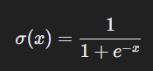
- Tanh:
  - Output: (−1,1)
  - Centered around zero, which can help in optimization compared to sigmoid.
- ReLU (Rectified Linear Unit):
  - Output: [0,∞)
  - Efficient and widely used in hidden layers. Can suffer from "dying neurons" where gradients become zero.
- Leaky ReLU:
  - Output: [0.01x,∞)
  - A variant of ReLU that allows a small gradient for negative inputs, mitigating the dying neuron problem.
- Softmax:
  - Used in the output layer for multi-class classification.
  - Converts logits into probabilities.
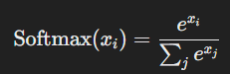
- Swish/ELU/GELU:
  - Advanced activation functions with better smoothness and performance in some cases.
  - Computational expense
Loss function
In deep learning, a loss function is a mathematical function that measures the difference between the predicted output of a model and the actual target values.

Loss Function vs. Cost Function
- Loss Function:
  - Measures the error for a single data point or instance.
- Cost Function:
  - Represents the average of the loss function over the entire dataset.

Types of Loss Functions:
Loss functions vary based on the type of problem: regression, classification, or other specialized tasks.
1. Regression Loss Functions
Used when the target variable is continuous.
- Mean Squared Error (MSE):
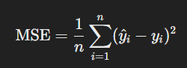
  - Penalizes larger errors more severely.
  - Suitable for predicting continuous values.

✅ When MSE is Good
- When Large Errors Are Unacceptable
  - If big mistakes are very costly, MSE helps because it penalizes them more.
  - Example: Predicting medical dosages or stock prices, where large errors can be dangerous or expensive.
- Mathematically Convenient
  - MSE is differentiable, which makes it easier to use in optimization (like gradient descent).

❌ When MSE is Bad
- Sensitive to Outliers
  - Since MSE squares errors, even one outlier can make the error huge.
  - Example: If you're predicting house prices and one house is extremely expensive, MSE might overreact.

- Mean Absolute Error (MAE):
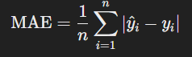
  - Less sensitive to outliers than MSE.
- Huber Loss: Combines MSE and MAE, robust to outliers.
For a predicted value y^​ and true value y, with delta δ (a threshold hyperparameter)
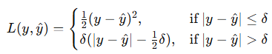
Where:
- ∣y−y^∣ is the absolute error.
- If the error is small (less than δ), it behaves like MSE (quadratic loss).
- If the error is large (greater than δ), it behaves like MAE (linear loss).

2. Classification Loss Functions
Used when the target variable is categorical.

- Binary Cross-Entropy (Log Loss):
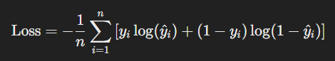
  - Used for binary classification problems.
  - Measures the dissimilarity between predicted probabilities and actual labels.

- Categorical Cross-Entropy:
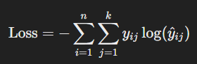
  - Generalization of binary cross-entropy for multi-class classification.
3. Specialized Loss Functions
- Hinge Loss:
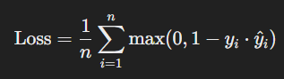
  - Used in Support Vector Machines (SVMs).
- Kullback-Leibler Divergence (KL Divergence): Measures the difference between two probability distributions.
- Custom Loss Functions: For tasks like object detection or reinforcement learning, loss functions like IoU loss, Smooth L1 Loss, or reward-based losses are used.

Key Points:
Relu, Softmax, CategoricalCrossEntropy => Multi-class
Relu, Sigmoid, BinaryCrossEntropy => Binary class
Relu, Linear Activation, {MSE, MAE, Huber Loss} =>Linear Regression

Optimizers
Optimizers are algorithms or methods used to minimize the loss function by updating the weights and biases of a neural network during training.

Role of Optimizers
- Minimize Loss:
  - Optimizers adjust the parameters (weights and biases) to minimize the difference between predicted and actual values (i.e., minimize the loss function).
- Improve Convergence:
  - They help the model converge to an optimal or near-optimal solution efficiently.
- Handle High-Dimensional Spaces:
  - Optimizers navigate the complex, high-dimensional loss landscape.

1. Gradient Descent (GD)
- Description:
  - Updates the parameters in the opposite direction of the gradient of the loss function.
θ=θ−η⋅∇J(θ)
  - θ: Model parameters (weights).
  - η: Learning rate.
  - ∇J(θ): Gradient of the loss function.
Drawbacks

1. Slow Convergence
❌ Large datasets take longer to train since each iteration updates parameters using the entire dataset (in Batch Gradient Descent).

2. Getting Stuck in Local Minima
❌ For non-convex functions, Gradient Descent can get stuck in local minima instead of finding the global minimum.

3. Vanishing Gradient Problem
❌ In deep networks, gradients can become too small, causing slow learning in early layers. This happens in sigmoid/tanh-based activations.

4. Sensitivity to Learning Rate
❌ Choosing the right learning rate (α\alphaα) is tricky:
- If α\alphaα is too small, convergence is very slow.
- If α\alphaα is too large, it may oscillate or diverge instead of converging.

5. Poor Performance on Saddle Points
❌ In high-dimensional spaces, gradient descent can get stuck at saddle points, where gradients are almost zero, leading to slow progress.

6. Requires Feature Scaling
❌ Gradient Descent works better with normalized data. If features have different scales, the optimization may be unstable or slow.

7. Computationally Expensive (Batch GD)
❌ Batch Gradient Descent computes the gradient over the entire dataset in each step, making it slow and memory-intensive for large datasets.

- Variants:
  - Batch Gradient Descent:
    - Uses the entire dataset to compute gradients.
    - Slow for large datasets.
  - Stochastic Gradient Descent (SGD):
    - Updates weights using a single data point at a time.
    - Faster but noisier.
    - Introduces noise, which can help escape local minima.
  - Mini-Batch Gradient Descent:
    - Updates weights using small batches of data.
    - Balances speed and stability.

Momentum
- Momentum enhances gradient descent by adding inertia, which accelerates convergence and smoothens oscillations.
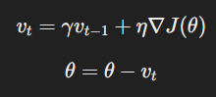
  - vt​: Velocity term.
  - γ: Momentum coefficient (e.g., 0.9).
  - η: Learning rate.
• Benefits:
- Speeds up convergence along gentle slopes.
- Reduces oscillations in steep directions.
• Drawbacks:
Think of it like a ball rolling down a hill - with too much momentum, it won't stop at the bottom but will roll up the other side. This can lead to:
- Slower convergence as the optimizer needs to correct its overshooting
- Potential instability in training
- Risk of missing narrow minima entirely
- May overshoot minima if momentum is too high.

- Adaptive optimizers
- Adaptive optimizers are optimization algorithms that adjust the learning rate dynamically for each parameter during training.
- Unlike standard optimizers like Stochastic Gradient Descent (SGD), which use a fixed learning rate, adaptive optimizers tailor the learning rate based on past gradients or gradient statistics, helping the model converge more effectively.
- Dynamic Learning Rate: They adjust the learning rate for each parameter individually, making training faster and more stable.
1. Adagrad
- Key Idea:
  - Adapts learning rates based on the magnitude of past gradients.

- Formula:
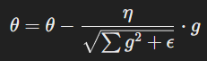
  - g: Gradient (a partial derivative of the loss function with respect to the parameter).
  - Summation(g^2): summation all previous weight
  - ϵ: Small constant for numerical stability.
- Advantages:
  - Works well for sparse data (e.g., text or images).
- Disadvantages:
  - Learning rate decreases over time, leading to slow convergence.

2. RMSprop
- Key Idea:
  - Improves upon Adagrad by using an exponentially decaying average of squared gradients instead of summing them.
- Formula:
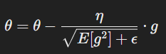
  - E[g2]: Exponentially weighted moving average of squared gradients.
- Advantages:
  - Handles non-stationary objectives better than Adagrad.
  - Stabilizes updates, preventing oscillations.

- Adam (Adaptive Moment Estimation) optimizer
The Adam (Adaptive Moment Estimation) optimizer combines concepts from momentum and adaptive learning rates.
Formulas:
- First Moment (Mean):
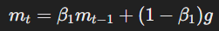
  - mt​: The exponentially weighted average of past gradients, representing the "mean" or first moment of gradients.
  - β1​: Decay rate for the moving average of gradients (typical value: 0.9).
  - g: Current gradient (i.e., the partial derivative of the loss function with respect to the parameter).
- Second Moment (Variance):
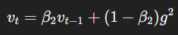
  - vt​: The exponentially weighted average of past squared gradients, representing the "variance" or second moment.
  - β2​: Decay rate for the moving average of squared gradients (typical value: 0.999).
  - g2: Square of the current gradient (element-wise).
- Bias Correction:
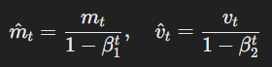
  - β1t​​: Powers of β1​ and β2​, decreasing as t (iteration count) increases.
  - m^t​: Bias-corrected first moment (mean).
  - v^t​: Bias-corrected second moment (variance).
- Update Rule:
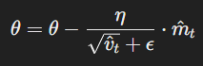
  - θ: Model parameters (weights and biases).
  - η: Learning rate.
  - m^t: Bias-corrected first moment.
  - v^t​​: Square root of the bias-corrected second moment.
  - ϵ: Small constant added for numerical stability (eg,10^{-8})
- Advantages:
  - Fast convergence.
  - Works well for large datasets and deep networks.
- Disadvantages:
  - Can sometimes overfit or fail to generalize well.
How to Choose the Right Optimizer
- Dataset Size:
  - Small: SGD or Momentum.
  - Large: Adam or RMSprop.
- Data Characteristics:
  - Sparse: Adagrad.
  - Non-stationary: RMSprop or Adam.
- Model Complexity:
  - Simple Models: SGD with momentum.
  - Deep Networks: Adam or RMSprop.

Key Parameters in Optimizers
- Learning Rate (η):
  - Controls the step size.
  - Too high: Divergence.
  - Too low: Slow convergence.
- Decay Rates (β1, β2​):
  - Control the smoothing effect in adaptive optimizers.
- Batch Size:
  - Affects stability and speed of updates
